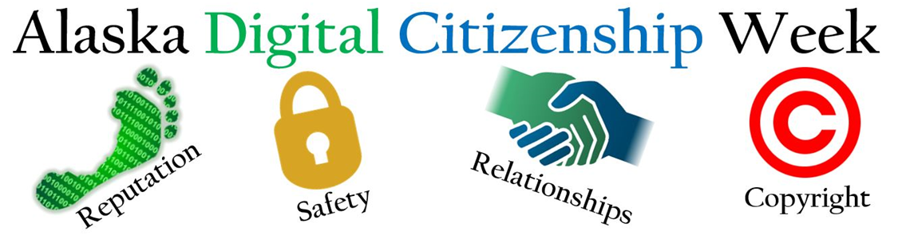
We appreciate that you are supporting your students by taking part in Alaska Digital Citizenship Week! We have put together THREE ways to participate in the daily themes which begin on Tuesday. By completing the Curriculum Tutorial on Monday and teaching lessons, you are well on your way to being Common Sense Certified! Whether you pursue certification or not, you are making an impact on our students’ success as members of a digital society.

Choose the activity or combination that best suits you and your students’ needs:
- Teach a 45-minute lesson. Each lesson has three delivery options: low/non tech, iBooks, and Nearpod. If time is tight, teach one suggested specific activity from the aligned lesson (linked in the chart below under Lesson).
- Show and discuss the highlighted video. This is the way to go if you only have 5-10 minutes to introduce the theme of the day.
- Share the corresponding Family Tips Sheets (linked in chart).
6-8 | Monday  Educate Yourself | Tuesday  Media Balance and Well Being | Wednesday  Privacy and Security | Thursday  Digital Footprint and Identity | Friday  Relationships and Cyberbullying
Lessons  45 minutes | Use today to create your account of Common Sense Media and begin exploring the digital citizenship curriculum and training. | My Media Use: A Personal Challenge | Don't Feed the Phish | The Power of Digital Footprints | Chatting Safely Online  OR  Responding to Online Hate Speech
Video options that may have Discussion Guides |  | Teen Voices: The Pressure to Stay Connected  3.25 minutes | Stay Safe from Phishing and Scams (Google for Education)  3.25 minutes | Digital Footprints  1.25 minutes | Teen Voices: Who You're Talking to Online  3.5 minutes
Family Tip Sheets | We encourage school leaders to send this letter home digitally or with students. | Help Kids Balance Their Media Lives  Media Balance & Well-Being | Privacy and Security | Help Kids Post, Comment, and Upload Responsibly | Help Kids Make Friends and Interact Safely Online

Bonus! – Consider giving your students the slides from “This Just In” and ask them to complete the “Breaking News!” handout from News and Media Literacy over the weekend and compare impressions on the following Monday. Digital Citizenship is a year round thing, right?

